# ***Indian Banking Transaction***

# **Here's a back story on Indian banking transactions**

1. **Early Days of Indian Banking**

The history of Indian banking dates back to the 18th century, with the establishment of the General Bank of India in 1786. However, it was the State Bank of India (SBI), founded in 1806 as the Bank of Calcutta, that played a pivotal role in shaping the country's banking landscape.

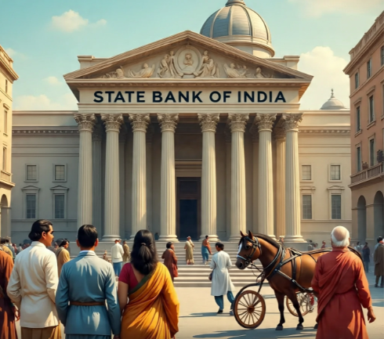

1. **Nationalization and Expansion**

In 1969, the Indian government nationalized 14 major banks, including SBI, to increase financial inclusion and provide banking services to rural areas. This move led to a significant expansion of banking services across the country.



1. **Digitalization and Innovation**

In recent years, Indian banking has undergone a significant transformation with the adoption of digital technologies. The launch of the Unified Payments Interface (UPI) in 2016 revolutionized digital payments, enabling users to transfer funds instantly between banks.



**Example: Paytm's UPI Success Story**

Paytm, a leading digital payments platform in India, has been at the forefront of UPI adoption. With over 300 million registered users, Paytm's UPI platform has processed billions of transactions, making it one of the most popular digital payment platforms in the country.



**Impact on Indian Banking**

The success of UPI and digital payment platforms like Paytm has transformed the Indian banking landscape, enabling:

1**. Increased financial inclusion**: Digital payment platforms have reached millions of unbanked and under banked individuals, providing them with access to financial services.

2**. Improved transaction efficiency**: UPI has enabled fast, secure, and low-cost transactions, reducing the need for cash and increasing the use of digital payments.

3. **Enhanced customer experience**: Digital payment platforms have provided users with a convenient, user-friendly, and seamless payment experience

The growth of digital payments in India has been phenomenal, with UPI transactions valued at over ₹100 trillion in 2022. As the country continues to adopt digital technologies, the future of Indian banking looks promising, with opportunities for innovation, growth, and financial inclusion.

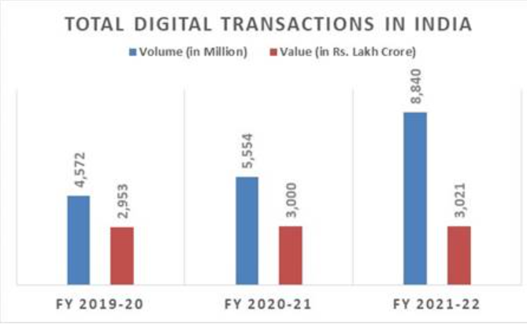

***How behavioural changes have led to the growth of Digital Payments in India***

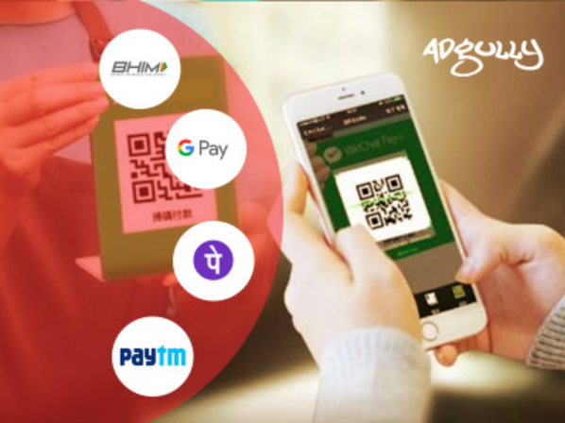

Unified Payments Interface (UPI) in India started with a pilot launch on April 11, 2016, by the National Payments Corporation of India (NPCI). It was designed to integrate multiple bank accounts into a single mobile application, enabling seamless fund transfers, merchant payments, and peer-to-peer transactions. The system aimed to provide a unified, user-friendly platform for digital payments, making them faster, more secure, and convenient.

UPI has seen tremendous growth in transaction volume and value since its launch, with billions of transactions processed monthly. The system has also expanded to include features like UPI Collect, Ru Pay credit card integration, and conversational payments.